A Minor Project I Report on

**ROOM FINDER**

Submitted in partial fulfillment of the requirements for the degree of

Bachelor of Engineering in Software Engineering at Pokhara University

**By**

**ARJUN ADHIKARI**

**ABHISHEK BHUSAL**

**ANURAG DAHAL**



**Department of Research and Development**

**GANDAKI COLLEGE OF ENGINEERING AND SCIENCE**

Lamachaur, Kaski, Nepal

**(November, 2021)**

A Minor Project I Report on

**ROOM FINDER**

Submitted in partial fulfillment of the requirements for the degree of

Bachelor of Engineering in Software Engineering at Pokhara University

**By**

**ARJUN ADHIKARI**

**ABHISHEK BHUSAL**

**ANURAG DAHAL**

**Supervisor**

**ER.TARA BAHADUR THAPA**



**Department of Research and Development**

**GANDAKI COLLEGE OF ENGINEERING AND SCIENCE**

Lamachaur, Kaski, Nepal

**(November, 2021)**

**BONAFIDE CERTIFICATE**

This is to certify that this project titled **ROOM FINDER** in partial fulfillment of the requirements for the degree of BACHELOR OF ENGINEERING IN SOFTWARE ENGINEERING is a bona fide work of **Arjun Adhikari, Abishek Bhusal and Anurag Dahal** under the supervision of **Er. Tara Bahadur Thapa**. It is further certified that this work doesn’t form part of any other project work on the basis of which a degree or award was conferred on any earlier occasion on this by any other candidate.

**Date of Evaluation**: November 11, 2021

|  |  |
| --- | --- |
| ………………………  **Er. Tara Bahadur Thapa**  (Project Supervisor) | ………………………  **Er. Sujan Tamrakar**  (Project Head) |
| ………………………  **Ashok Raj Parajuli**  (Vice Principal) | ………………………  **Er. Shiva Ram Dam**  (External Evaluator) |

**ACKNOWLEDGEMENT**

We would like to express our sincere gratitude and appreciation to all who gave us the opportunity to do this project. Completion of this project could not have been accomplished without the support of many individuals and the college administration. First, we would like to give special gratitude to the project supervisor, Er. Tara Bahadur Thapa for providing necessary information regarding the project and also for the support while completing the project. Thanks to our parents for their encouragement and kind cooperation. We express our deepest gratitude to the principal Mr. Birendra Khadka, vice-principal Mr. Ashok Raj Parajuli, Er. Sujan Tamrakar, Project Head for inspiring and supporting us during the entire project. At last, but not least we are thankful to all our teachers and friends who have been always helping and encouraging us throughout this project.

Arjun Adhikari

Abishek Bhusal

Anurag Dahal

Gandaki College of Engineering and Science

Lamachaur, Pokhara

**ABSTRACT**

“Room Finder” is a mobile application that maps available rental rooms in a certain location. System admin publishes rooms with detailed descriptions powered by images and videos. Any ordinary user can explore these rooms in specified locations and contact owners through our application.

**TABLE OF CONTENTS**

|  |  |
| --- | --- |
| INTRODUCTION …………………………………....…... | 1 |
| 1.1 BACKGROUND ………………………………….. | 1 |
| 1.2 PROBLEM STATEMENT ………………………... | 1 |
| 1.3 OBJECTIVES …………………………………….. | 2 |
| 1.4 IMPLICATION ………………………………….... | 2 |
| LITERATURE REVIEW ..….……………………………. | 3 |
| TOOLS AND METHODOLOGIES ……………………... | 4 |
| 3.1 REQUIRED TOOLS …………………………….... | 4 |
| 3.2 APPROACH USED ………………………………. | 5 |
| 3.3 USE CASE DIAGRAM ………………………... | 6 |
| 3.4 SYSTEM SEQUENCE DIAGRAM …………….... | 9 |
| 3.5 ENTITY RELATIONSHIP DIAGRAM ………….. | 11 |
| RESULTS AND DISCUSSIONS ………..……………….. | 12 |
| 5.1 LIMITATIONS ………….………………………. | 12 |
| 5.2 FUTURE IMPROVEMENTS …………….…….. | 12 |
| CONCLUSION ………….……………………………….. | 13 |
| Bibliography ………………………………….…………... | 14 |
| Appendix …....…………………………………………... | 15 |

## 

## 

**List of Figures**

Figure 3.2.1: Agile Model steps ……………………….. ...............................5 Figure 3.3.1: Use Case Diagram (UCD) of Room Finder ...............................5

Figure 3.4.1: SSD of Adding new Room …………..........................................7 Figure 3.4.2: SSD of Editing a Room …………...............................................7

Figure 3.5.1: ERD of RoomFinder ………………………………...….............8

Chapter 1

## **INTRODUCTION**

**1.1** **BACKGROUND**

**Room Finder** is a Mobile Application which helps people to find rooms near them or any other place. People from different places can explore our application and find rooms which are available near them. System admin can publish rooms with detailed descriptions powered by images and videos. Admin can edit Room’s information. An ordinary user who is searching for rooms can directly contact owners through our application.

**1.2 PROBLEM STATEMENT**

Finding available rentable rooms in a certain area is a troublesome task in itself. Moreover, finding rooms of one’s choice is tedious. People searching for rooms cannot have much information about available rooms, its feedback and reviews from previous customers. They also have very few options to compare one room with another in terms of the room's environment, price, location and other faculties. This leaves people searching for rooms helpless. Also room owners don't usually tend to provide maximum possible facilities to their customers these days, since they don't have to compete with others.

**1.3 OBJECTIVES**

* To provide information about available rooms on the basis of location, price and other details.
* Provide filtering mechanism on the basis of price range , location, owner details and more.
* Provide room’s information through text and photos.

**1.4** **IMPLICIATION**

Our project will help every person who is searching for rooms.They should not roam here and there and ask every house for rental rooms.This application will make their work easier and faster.Vendors can create their detailed descriptions about their rooms. It will help to save valuable time for every user.

Chapter 2

**LITERATURE REVIEW**

Many web applications and mobile applications have already been developed in the market which provide Home Management Systems. Some of them are listed below:

* **RoomFinder Nepal :**

**RoomFinder Nepal**, developed by Veda IT pvt.ltd. is a platform for searching for rooms, flat, apartment, hostel , shutter ,commercial spaces. We can customize our search for houses with big parking spaces and plenty of water available. Owners can publish their houses for sale too, through this application.

* **GharBheti**

**GharBheti** is a platform to connect buyers and sellers, tenants and landlords in Nepal. We can find the best properties and houses at attractive and best prices through this website.

Chapter 3

**TOOLS AND METHODOLOGIES**

**3.1** **REQUIRED TOOLS**

The following tools have been used for the development of the listed portions of this application.

Design and wireframes

* Adobe XD
* Balsamiq Mockups

Front End

* User Interface in Dart (Flutter)
* Admin Interface in HTML

Backend APIs

* PHP

Database

* MySQL

Version Controlling

* Git and Github

Extra Tools

* Visual Studio Code
* Android Studio

**3.2 APPROACH USED**

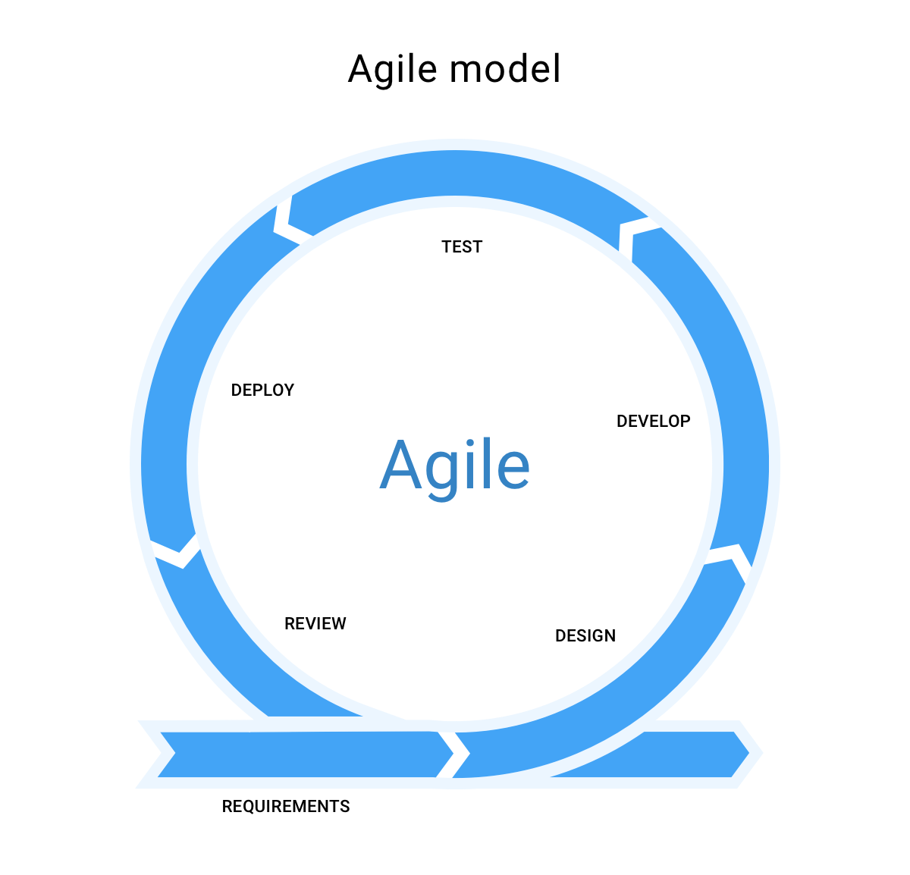

**Figure 3.2.1 Agile Model steps**

**3.3 USE CASE DIAGRAM**

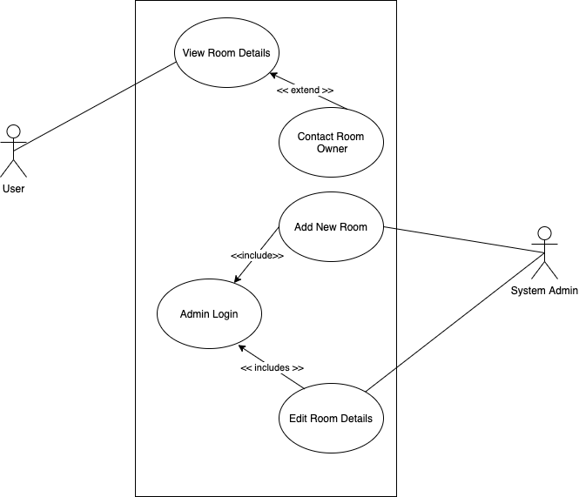

**Fig: 3.3.1: Use Case Diagram (UCD) of Room Finder**

**Use Case UC1: View Room Details**

**Primary Actor:** User

**Overview**: This use case allows an user to view details of a room.

**Preconditions**: choosenRoom is set.

**Postconditions**:

**Use Case UC2: Contact Room Owner**

**Primary Actor:** User

**Overview**: This use case allows an user to contact the owner of a room.

**Preconditions**: choosenRoom is set.

**Postconditions**: User is redirected to phone app to make a call.

**Use Case UC3: Add New Room**

**Primary Actor:** System Admin

**Overview**: This use case allows system admin to add new rooms in the system.

**Preconditions**: Verified login exists.

**Postconditions**: New room is added.

**Use Case UC4: Edit Room Details**

**Primary Actor:** System Admin

**Overview**: This use case allows system admin to edit details of rooms in the system.

|  |  |
| --- | --- |
| **Preconditions** | * Verified Login Exists * Valid room exists |

|  |  |
| --- | --- |
| **Postconditions** | * Room details are updated. |

**3.4 SYSTEM SEQUENCE DIAGRAM (SSD)**

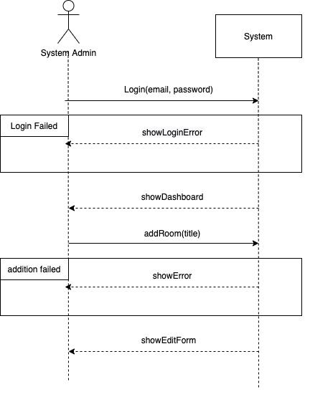

**Figure 3.4.1: SSD of Adding new Room**

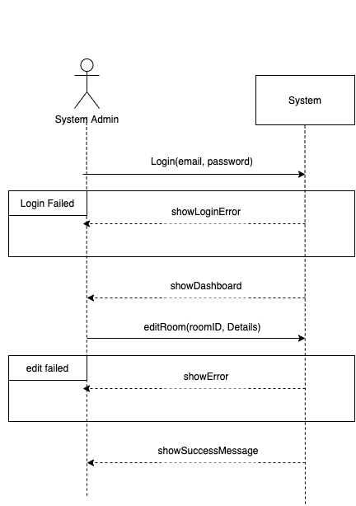

**Figure 3.4.2: SSD of Editing a Room**

**3.5 ENTITY RELATIONSHIP DIAGRAM (ERD)**

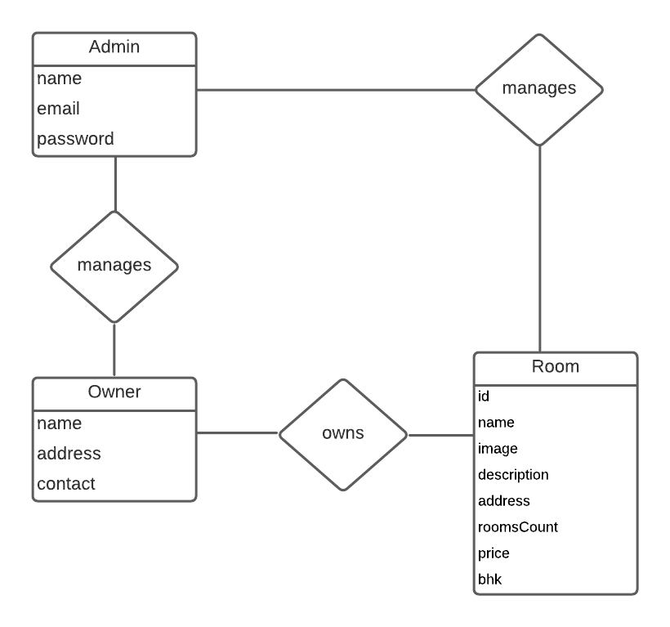

**Figure 3.5.1: ERD of RoomFinder**

Chapter 4

**RESULT AND DISCUSSION**

Roomfinder helps users see available rentable rooms. It allows system admin to add new rooms and edit details of existing rooms. Through roomFinder, users can contact room owners. Users can filter rooms on the basis of price range, location, owner name, and other room details.

**3.4 LIMITATION**

1. Vendors can not publish their rooms by themselves.
2. It is tedious for system admin to update room details for each vendor. If vendors could do that on their own, it would have been easier.
3. Other users cannot post their reviews and comments.

**3.4 FUTURE IMPROVEMENT**

This project can be improved in following ways

1. Making it available for vendors to manage their rooms on their own.
2. Developing means to receive feedback from users.
3. Allowing users to filter rooms by preferred locations.

Chapter 5

**CONCLUSION**

This system helps people to find rooms near them or any other place. People from different places can explore through our application and find rooms which are available near them. System admin can publish rooms with detailed descriptions powered by images and videos. Admin can edit Room’s information. An ordinary user who is searching for rooms can directly contact owners through our application.

**BIBLIOGRAPHY**

Agile Model Diagram

<https://lh3.googleusercontent.com/xExOJYzP2K3su8NcSabsLozpM8jYVplZzireNIm10Ndt6nrtsimSuKT6tz8K9MuavNJSRxYq14-sWh5QKg8VYa1jkAyd4wOIbD8dUz6T7zan6PSl3GBpBeMxoo6vJl9tQHbL3dT7>

UCD and SSD made from <https://draw.io>

ERD made from <https://lucid.co/>

**Appendix**

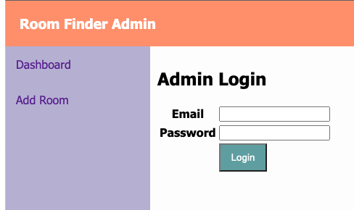

**Login Interface (web)**

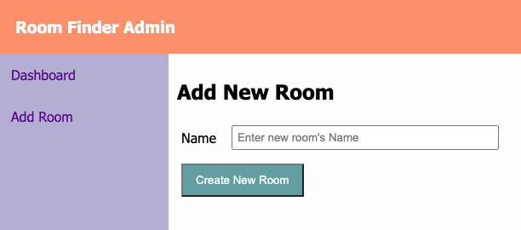

**Add new room Interface(web)**

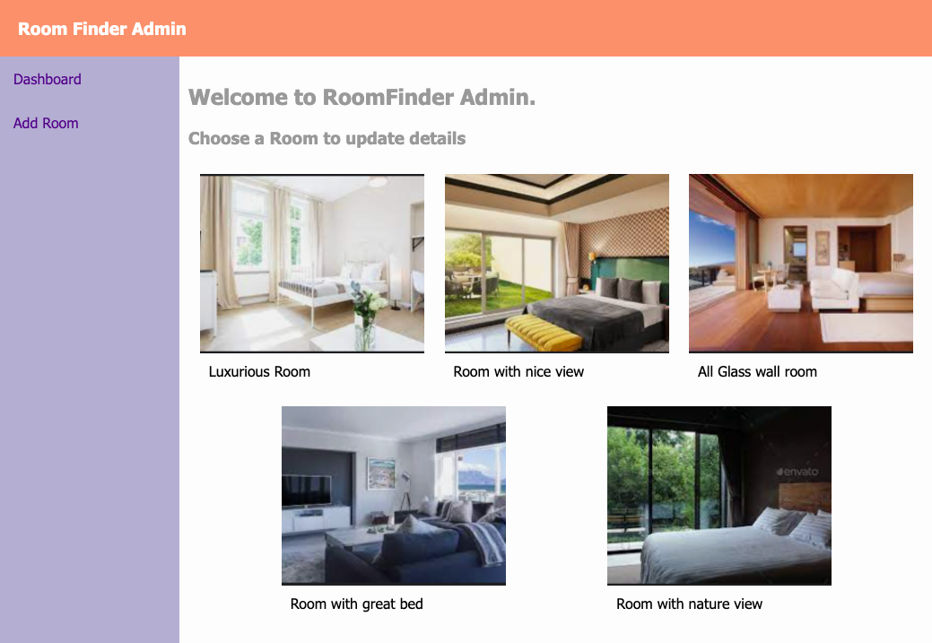

**Dashboard Interface (web)**

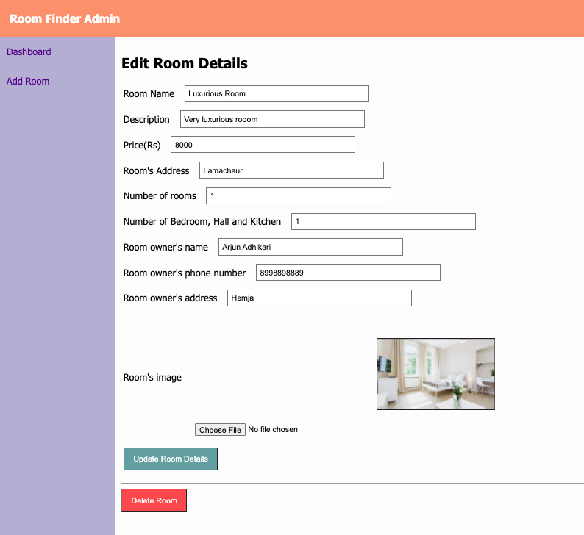

**Room Editing Interface (web)**

|  |  |
| --- | --- |
| **image12.png** | **image11.png** |
| **Home Page( Android App)** | **Room Details Page (Android App)** |

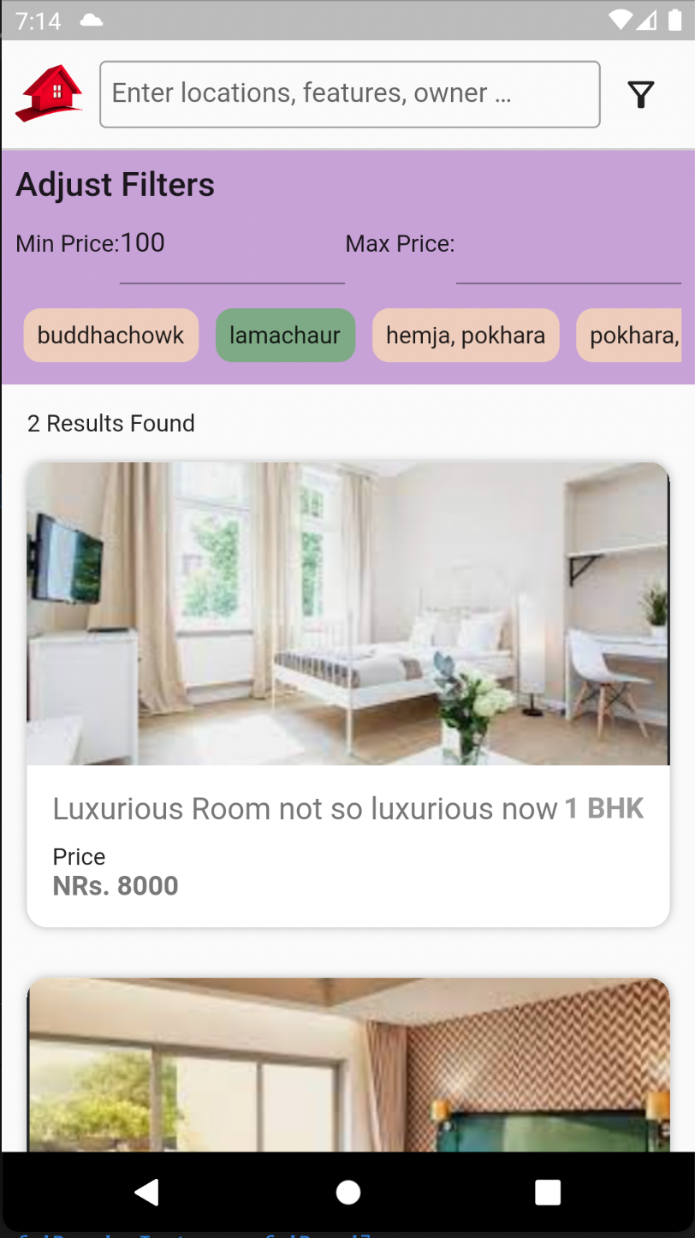

**Home Page with Filters ( Android App)**